objective: To make a clock skipping the specific second and minute.

Introduction:
A digital clock is a type of timekeeping device that displays the current time in a digital format, typically using numbers and sometimes symbols. Here is some basic information about digital clocks:
Display Format: Digital clocks display the time in a numerical format, typically using digits (0-9) to represent hours, minutes, and sometimes seconds. The numbers change to indicate the current time.
Accuracy: Digital clocks are known for their high accuracy in timekeeping. They are often powered by quartz crystal oscillators, which vibrate at a precise frequency, allowing them to keep time with great accuracy.

Power Source: Digital clocks are usually powered by electricity, batteries, or a combination of both. Wall-mounted digital clocks are often connected to the electrical grid, while smaller ones, like alarm clocks, may run on batteries.

Display Types: There are different types of digital clock displays, including LED (Light Emitting Diode), LCD (Liquid Crystal Display), and OLED (Organic Light Emitting Diode). Each type has its advantages in terms of energy efficiency, visibility, and size.

Features: Modern digital clocks often come with additional features beyond just displaying the time. These features may include alarms, snooze functions, date displays, temperature readings, and backlighting for nighttime visibility.

Variety of Designs: Digital clocks come in various designs and sizes to suit different needs and preferences. They can be found in alarm clock form, wall clocks, desk clocks, and even integrated into various electronic devices like microwave ovens and smartphones.

Synchronization: Some digital clocks can synchronize with external time sources, such as atomic clocks or internet time servers, to maintain a high level of accuracy. This is particularly important in applications like aviation, where precise timekeeping is essential.

Applications: Digital clocks are widely used in both residential and commercial settings. They can be found in homes, offices, schools, transportation systems, and many other places where timekeeping is important.

Overall, digital clocks have become a ubiquitous and reliable way to keep track of time, offering both accuracy and convenience in a variety of settings.

A 7-segment display decoder is an electronic circuit that translates binary or BCD (Binary Coded Decimal) inputs into signals that illuminate a 7-segment LED (Light Emitting Diode) display. Each of the seven segments on the display represents a numerical digit (0-9) or other characters (like A-F for hexadecimal). The decoder takes input data and activates specific segments to display the corresponding digit or symbol. It's commonly used in digital devices like calculators, digital clocks, and digital meters to visually represent numeric information. The decoder simplifies the process of driving 7-segment displays, making it easier to showcase numerical values in a clear and readable format.

A digital counter is an electronic circuit or device used to count events or occurrences in a digital format. It typically employs flip-flops or other digital logic elements to keep track of the number of input signals or pulses it receives. Digital counters can count up or down, and they come in various configurations, such as binary or BCD (Binary Coded Decimal). They find wide applications in areas like electronics, automation, and computing, including tasks like frequency measurement, timekeeping, and controlling sequential processes. Digital counters offer precise and efficient counting capabilities, making them essential components in various electronic systems and instruments.
Flip Flop we used:
We had mainly used JK Flip Flop here. Because JK flip flop is more convenient to use because we can find more don’t care here.
A JK flip-flop, also known as a JK flip-flop or JK latch, is a type of sequential logic circuit that can store and manipulate binary information. It is one of the fundamental building blocks in digital electronics and is widely used in various applications. Here's an explanation of how a JK flip-flop works:
Basic Structure:
- A JK flip-flop typically has two inputs: J (for "set") and K (for "reset").
- It also has two outputs: Q and Q' (the complement of Q).
Operation:
- The key feature of a JK flip-flop is its ability to toggle its state when specific conditions are met.
- When both J and K inputs are set to 0, the flip-flop maintains its current state.
- When J is set to 1 and K is set to 0, the flip-flop is forced to the "SET" state, meaning its Q output becomes 1.
- When J is set to 0 and K is set to 1, the flip-flop is forced to the "RESET" state, meaning its Q output becomes 0.
- When both J and K are set to 1, the flip-flop toggles its state. If Q was 0, it becomes 1, and if Q was 1, it becomes 0.
Clock Input :
- In many practical applications, a clock input (C or CLK) is added to the JK flip-flop. Changes in the J and K inputs are only registered and affect the outputs when a clock pulse arrives.
- On the rising or falling edge of the clock signal, the flip-flop reads the J and K inputs and updates its outputs accordingly.
Use Cases:
- JK flip-flops are versatile and can be used for various tasks in digital circuits, such as data storage, frequency division, and sequential logic operations.
- They are commonly used to build more complex sequential circuits, like shift registers and counters.
In summary, a JK flip-flop is a digital logic component with inputs for setting, resetting, and toggling its output state. It can store binary information and is widely used in digital systems for various purposes, including control and data manipulation.

We used a synchronous up counter here:
A synchronous up counter is a type of digital circuit used in digital logic design to count upwards, incrementing its output value by one for each clock pulse it receives. It is "synchronous" because the counting operation is synchronized with a clock signal. Here's an explanation of how a synchronous up counter works:
Components of a Synchronous Up Counter:
- Flip-Flops: A synchronous up counter consists of a series of flip-flops, typically D flip-flops or JK flip-flops, connected in a cascading fashion.
- Clock Input (CLK): Each flip-flop has a clock input, usually labeled CLK. The CLK input is used to synchronize the counting operation with the clock signal. Outputs (Q): The outputs of the flip-flops, labeled Q0, Q1, Q2, etc., represent the binary count values. These outputs are connected in such a way that they form a binary number, and this number increases by one for each clock pulse.
Operation:
- Initialization: To initialize the counter, you set all the flip-flops to their initial states. For a synchronous up counter, this typically means setting all the flip-flops to 0.
- Clock Pulse: When a clock pulse is received at the CLK input, all the flip-flops simultaneously update their states based on their current inputs and the clock signal.
- Binary Counting: Each flip-flop represents a different bit of the binary count. For example, the first flip-flop (Q0) represents the least significant bit (LSB), the second flip-flop (Q1) represents the next bit, and so on. As the counter receives clock pulses, it counts upwards in a binary fashion.
- Ripple Carry: In a synchronous up counter, the output of each flip-flop (Q0, Q1, Q2, etc.) is connected to the clock input of the next flip-flop in the sequence. This means that when a flip-flop toggles from 1 to 0 (overflowing from its maximum count to 0), it triggers the next flip-flop to increment its count. This creates a ripple carry effect, allowing the counter to count from 0 to its maximum value and then roll over to 0 again.
- Count Limit: The maximum count value of the counter depends on the number of flip-flops used. For example, a 4-bit synchronous up counter can count from 0 (binary 0000)to 15 (binary 1111) before rolling over to 0.
Synchronous up counters are widely used in digital systems for tasks like frequency division, event counting, and control applications where precise counting is required. They ensure that all flip-flops change their states simultaneously, avoiding issues associated with asynchronous counters where timing differences can cause glitches and errors.

We used 7 segment display here:
A 7-segment display is a type of electronic display device used to represent numbers and sometimes a few letters or symbols. It consists of seven individual LED (Light Emitting Diode) segments arranged in a specific pattern, typically in the shape of the number "8." Each of these segments can be individually lit or turned off to display different numerical digits (0-9) and some characters (such as A, B, C, etc.).
Each segment can be activated or deactivated independently, allowing you to create numerical and alphanumeric representations on the display. By selectively lighting the appropriate segments, you can display numbers or characters. For example, to display the digit "1," you would activate segments B and C, and to display the digit "8," you would activate all seven segments.
7-segment displays are commonly used in various applications where numeric information needs to be displayed, such as digital clocks, calculators, microwave ovens, and digital meters. They are relatively simple and easy to control, making them popular in both electronic projects and commercial products. There are two main types of 7-segment displays: common anode and common cathode, which differ in how they are connected and controlled in a circuit.

Truth Table:
Table for 7 segment display decoder from 0 to 9:
Digit | D | C | B | A | a | b | c | d | e | f | g
0 | 0 | 0 | 0 | 0 | 1 | 1 | 1 | 1 | 1 | 1 | 0
1 | 0 | 0 | 0 | 1 | 0 | 1 | 1 | 0 | 0 | 0 | 0
2 | 0 | 0 | 1 | 0 | 1 | 1 | 0 | 1 | 1 | 0 | 1
3 | 0 | 0 | 1 | 1 | 1 | 1 | 1 | 1 | 0 | 0 | 1
4 | 0 | 1 | 0 | 0 | 0 | 1 | 1 | 0 | 0 | 1 | 1
5 | 0 | 1 | 0 | 1 | 1 | 0 | 1 | 1 | 0 | 1 | 1
6 | 0 | 1 | 1 | 0 | 1 | 0 | 1 | 1 | 1 | 1 | 1
7 | 0 | 1 | 1 | 1 | 1 | 1 | 1 | 0 | 0 | 0 | 0
8 | 1 | 0 | 0 | 0 | 1 | 1 | 1 | 1 | 1 | 1 | 1
9 | 1 | 0 | 0 | 1 | 1 | 1 | 1 | 1 | 0 | 1 | 1

Table for 7 segment display decoder from 0 to 5:
Digit | D | C | B | A | a | b | c | d | e | f | g
0 | 0 | 0 | 0 | 0 | 1 | 1 | 1 | 1 | 1 | 1 | 0
1 | 0 | 0 | 0 | 1 | 0 | 1 | 1 | 0 | 0 | 0 | 0
2 | 0 | 0 | 1 | 0 | 1 | 1 | 0 | 1 | 1 | 0 | 1
3 | 0 | 0 | 1 | 1 | 1 | 1 | 1 | 1 | 0 | 0 | 1
4 | 0 | 1 | 0 | 0 | 0 | 1 | 1 | 0 | 0 | 1 | 1
5 | 0 | 1 | 0 | 1 | 1 | 0 | 1 | 1 | 0 | 1 | 1

Table for 7 segment display decoder from 0 to 3:
Digit | D | C | B | A | a | b | c | d | e | f | g
0 | 0 | 0 | 0 | 0 | 1 | 1 | 1 | 1 | 1 | 1 | 0
1 | 0 | 0 | 0 | 1 | 0 | 1 | 1 | 0 | 0 | 0 | 0
2 | 0 | 0 | 1 | 0 | 1 | 1 | 0 | 1 | 1 | 0 | 1
3 | 0 | 0 | 1 | 1 | 1 | 1 | 1 | 1 | 0 | 0 | 1

Table for 7 segment display decoder from 0 to 2:
Digit | D | C | B | A | a | b | c | d | e | f | g
0 | 0 | 0 | 0 | 0 | 1 | 1 | 1 | 1 | 1 | 1 | 0
1 | 0 | 0 | 0 | 1 | 0 | 1 | 1 | 0 | 0 | 0 | 0
2 | 0 | 0 | 1 | 0 | 1 | 1 | 0 | 1 | 1 | 0 | 1
State diagram for synchronous up counter from 0 to 9:

Table for synchronous up counter from 0 to 9:
Q_{D} Q_{C} Q_{B} Q_{A} | Q_{D+} Q_{C+} Q_{B+} Q_{A+} | J_{D} K_{D} | J_{C} K_{C} | J_{B} K_{B} | J_{A} K_{A}
0 0 0 0 | 0 0 0 1 | 0 X | 0 X | 0 X | 1 X
0 0 0 1 | 0 0 1 0 | 0 X | 0 X | 1 X | X 1
0 0 1 0 | 0 0 1 1 | 0 X | 0 X | X 0 | 1 X
0 0 1 1 | 0 1 0 0 | 0 X | 1 X | X 1 | X 1
0 1 0 0 | 0 1 0 1 | 0 X | 0 X | 0 X | 1 X
0 1 0 1 | 0 1 1 0 | 0 X | 0 X | 1 X | X 1
0 1 1 0 | 0 1 1 1 | 0 X | X 0 | X 0 | 1 X
0 1 1 1 | 1 0 0 0 | 1 X | X 1 | X 1 | X 1
1 0 0 0 | 1 0 0 1 | X 0 | 0 X | 0 X | 1 X
1 0 0 1 | 0 0 0 0 | X 1 | 0 X | 0 X | X 1

State diagram for synchronous up counter from 0 to 9 (Skip 1):

Table for synchronous up counter from 0 to 9(Skip 1):
Q_{D} Q_{C} Q_{B} Q_{A} | Q_{D+} Q_{C+} Q_{B+} Q_{A+} | J_{D} K_{D} | J_{C} K_{C} | J_{B} K_{B} | J_{A} K_{A}
0 0 0 0 | 0 0 1 0 | 0 X | 0 X | 1 X | 0 X
0 0 1 0 | 0 0 1 1 | 0 X | 0 X | X 0 | 1 X
0 0 1 1 | 0 1 0 0 | 0 X | 1 X | X 1 | X 1
0 1 0 0 | 0 1 0 1 | 0 X | X 0 | 0 X | 1 X
0 1 0 1 | 0 1 1 0 | 0 X | X 0 | 1 X | X 1
0 1 1 0 | 0 1 1 1 | 0 X | X 0 | X 0 | 1 X
0 1 1 1 | 1 0 0 0 | 1 X | X 1 | X 1 | X 1
1 0 0 0 | 1 0 0 1 | X 0 | 0 X | 0 X | 1 X
1 0 0 1 | 0 0 0 0 | X 1 | 0 X | 0 X | X 1

State diagram for synchronous up counter from 0 to 5:

Table for synchronous up counter from 0 to 5:
Q_{C} Q_{B} Q_{A} | Q_{C+} Q_{B+} Q_{A+} | J_{C} K_{C} | J_{B} K_{B} | J_{A} K_{A}
0 0 0 | 0 0 1 | 0 X | 0 X | 1 X
0 0 1 | 0 1 0 | 0 X | 1 X | X 1
0 1 0 | 0 1 1 | 0 X | X 0 | 1 X
0 1 1 | 1 0 0 | 1 X | X 1 | X 1
1 0 0 | 1 0 1 | X 0 | 0 X | 1 X
1 0 1 | 1 1 0 | X 1 | 0 X | X 1

State diagram for synchronous up counter from 0 to 3:

Table for synchronous up counter from 0 to 3:
Q_{B} Q_{A} | Q_{B+} Q_{A+} | J_{B} K_{B} | J_{A} K_{A}
0 0 | 0 1 | 0 X | 1 X
0 1 | 1 0 | 1 X | X 1
1 0 | 1 1 | X 0 | 1 X
1 1 | 0 0 | X 1 | X 1

State diagram for synchronous up counter from 0 to 2:

Table for synchronous up counter from 0 to 2:
Q_{B} Q_{A} | Q_{B+} Q_{A+} | J_{B} K_{B} | J_{A} K_{A}
0 0 | 0 1 | 0 X | 1 X
0 1 | 1 0 | 1 X | X 1
1 0 | 0 0 | X 0 | 1 X

Circuit Diagram:
Circuit diagram for 7 segment display decoder from 0 to 9:
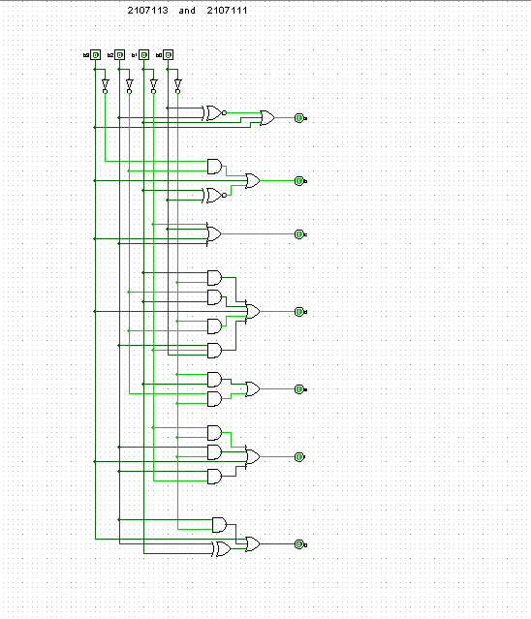

Circuit diagram for 7 segment display decoder from 0 to 5:
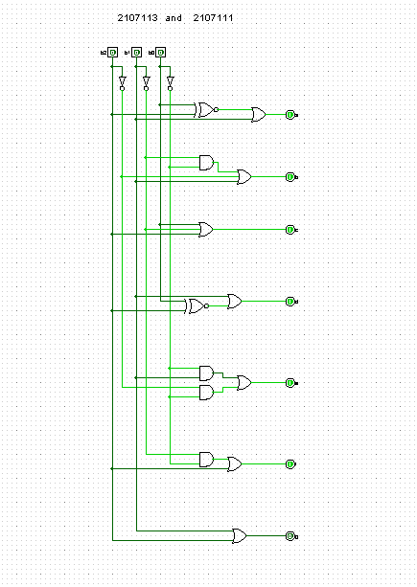

Circuit diagram for 7 segment display decoder from 0 to 3:
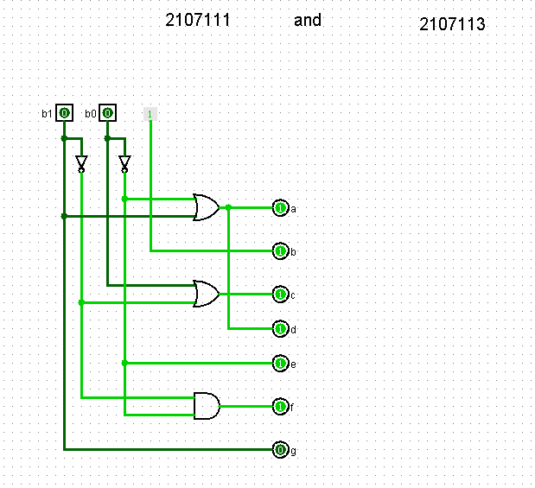
Circuit diagram for 7 segment display decoder from 0 to 2:
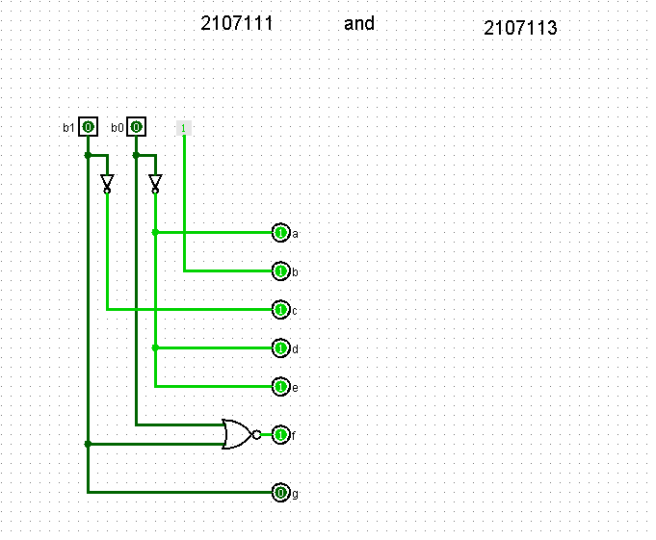
Circuit diagram for synchronous up counter from 0 to 9 (Skip 1):
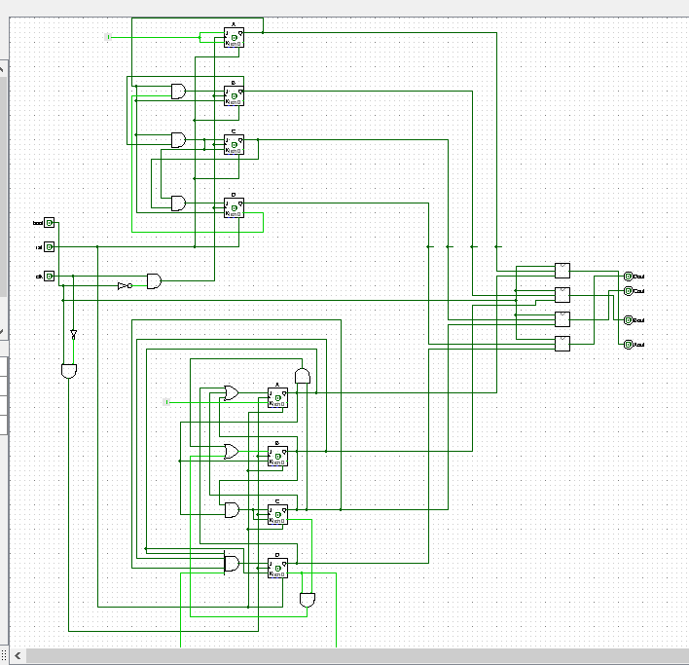
Circuit diagram for synchronous up counter from 0 to 5:
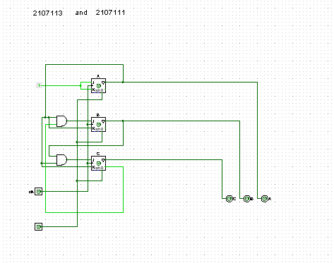
Circuit diagram for synchronous up counter from 0 to 3 or 9:
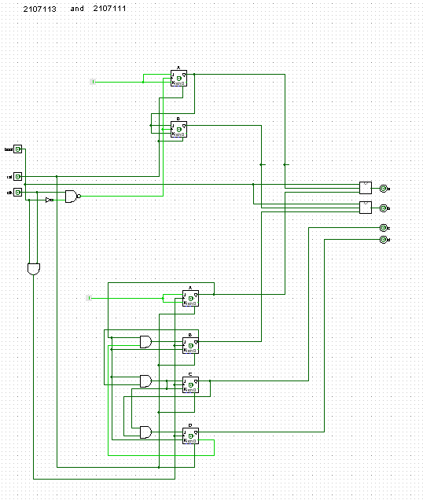
Circuit diagram for synchronous up counter from 0 to 2:
